Analysis of ocular hemodynamic using combined
STdOCT and ultrasonic methods
M. E. Danielewska,¹ D. Szlag,² D. R. Iskander³ and M. Wojtkowski²
¹Institute of Physics, Wroclaw University of Technology, Wybrzeże Wyspiańskiego 27, 50-370 Wroclaw, Poland
² Institute of Physics, Nicolaus Copernicus University, Grudziadzka 5, 87-100 Torun, Poland
³ Institute of Biomedical Engineering and Instrumentation, Wroclaw University of Technology,
Wybrzeże Wyspiańskiego 27, 50-370 Wroclaw, Poland
Abstract—A new approach to the human eye hemodynamic assessment and analysis is presented. Combined method of ultrasonic ocular pulse measurements and registration of retinal blood flow velocity using STdOCT synchronically with heart activity was applied. Spectral analysis and coherence analysis were used to characterize frequency components of considered signals. The fundamental frequency related to the heart rate present in the ECG signal was also noticed in the blood pulsation, longitudinal corneal apex displacements, and the ocular pulse spectrum derived from the STdOCT measurements. The proposed technique of new, noninvasive ocular circulation measurements and analysis might be helpful in diagnosis vascular ocular diseases such as, for example, the normal tension glaucoma.
Received xxx x, 2011; revised xxx x, 2011; accepted xxx x, 2011; published xxx x, 2011

Investigating human eye hemodynamic is important in diagnosis of many eye vascular diseases, particularly glaucoma [1]. Nowadays, increased intraocular pressure (IOP) is not the only crucial risk to develop glaucoma. Normal tension glaucoma (NTG) is a very common form of this disease. However, the aetiology of NTG has been considered as unknown. Blood circulation disorders inside the eye, as well as those in the cardiovascular system may play a significant role in the disease progression leading to the optic nerve damage.
Pulsatile ocular blood flow (POBF) and IOP variations are the fundamental components of the phenomenon, known as the ocular pulse [2]. Expansion of the corneal and scleral surface is mainly caused by the ocular pulse, which depends also on the heart activity [3,4]. Results obtained by Evans showed, that amplitudes of the ocular pulse for healthy and glaucomatous patients, calculated using spectral analysis, are different [5]. Therefore, examining relationships between the ocular pulse and cardiovascular activity might bring information about blood propagation to the eye globe.
Elementary methods of ocular blood flow measurements, used by many ophthalmologists, are invasive (fluorescein angiography) or limited by poor resolution (laser Doppler flowmetry) [6,7]. On the other hand, methods of in-vivo retinal blood flow measurements, which are based on the optical Doppler effect combined with time [8-10] or Fourier domain optical coherence tomography (OCT) [11-12], are limited by low acquisition rate or measurement time. One of the most promising methods to measure and image ocular blood flow is joint spectral and time domain Optical Coherence Tomography (STdOCT) [13]. This technique offers a high sensitivity preserved in acquisition speed over 50 000 lines/s [14,15].
The main goal of this study was to combine the following methods: (i) noninvasive measurement of the ocular pulse with ultrasound sensors on one eye, (ii) registration of blood flow velocity with STdOCT in the fellow eye, and (iii) measurement of heart activity.
Longitudinal corneal apex displacements (LCAD) of the right eye were measured noninvasively using ultrasonic transducer, functioning at a frequency of 0.8 MHz. Technical details of this method was described earlier [16]. The retinal vessels of the left eye were registered using typical SOCT setup. All cross-sectional images were measured in the same position with small lateral range. The blood flow velocity in selected retinal vessel was retrieved using STdOCT method with high transverse oversampling for establishing accurate data of blood flow velocity and at reasonable high frame rate to examine in-vivo retinal hemodynamic. Involuntary movements of object introduce offset in flow velocities. These artifacts were removed using STdOCT bulk motion correction algorithm described in [17]. SOCT data were directly synchronized with pulseoximeter (one A-scan corresponds to one point in pulse plot). A schematic diagram of the measurement setup is presented in Fig.1.
Synchronically with the signal of retinal blood flow (RBF), the following signals of the heart activity were recorded: electrocardiogram (ECG) and pulse wave using pulseoximeter, placed on the right earlobe. Measurements were carried out five times for two healthy volunteers aged 27 and 29, who did not exhibit any eye and heart pathologies. LCAD signal was sampled at a frequency of 100 Hz, while the remaining signals at 66 kHz.

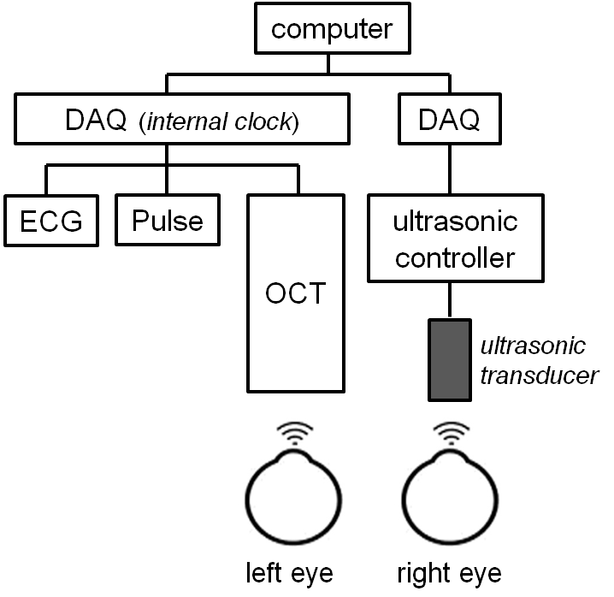
Fig. 1. The concept of measurements the ocular pulse (right eye) with ultrasonic transducer, retinal blood flow using OCT (left eye) synchronically with ECG and pulse signals.
Obtained data were numerically processed. First the signals were detrended by removing a linear trend. Then, a band-pass filter (0.1–20 Hz) was applied to remove frequencies unrelated to the heart activity.
LCAD and heart activity related signals were considered before [18,19]. To compare signal of blood flow velocity registered with STdOCT to signals of LCAD and cardiac activity, a technique to extract RBF velocity was applied. This consisted of fitting a 2D Gaussian function with parameters (A, µ_{x}, µ_{y}, σ_{x}, σ_{y}, δ) to an image formed by concatenation of 5000 A-scans. The parameter A describes the background around the measured vessel, while (µ_{x}, µ_{y}), (σ_{x}, σ_{y}) and δ describe the center, spread and azimuth of the Gaussian fit, respectively. Subsequently, the volume enclosed by the Gaussian fit (±3σ_{x}; ±3σ_{y}) was used as an estimator (arbitrary units) of the retinal blood flow.
Finally, Fourier Transform was applied to calculate spectral characteristics for all signals. To obtain information about phase compliance between corresponding frequency components contained in two given signals, the coherence function was evaluated.
In this study we present results obtained for subject I (27 years old woman, emmetrope). The time and spectral characteristics of all registered signals are shown in Fig.2 and Fig.3, respectively.
In all presented in Fig.2 signals pulsative character of their time representations are observed. Moreover, they are nonstationary [18], meaning that their frequency components vary in time. The main factor, which influences these phenomena is the heart rate variability (HRV).
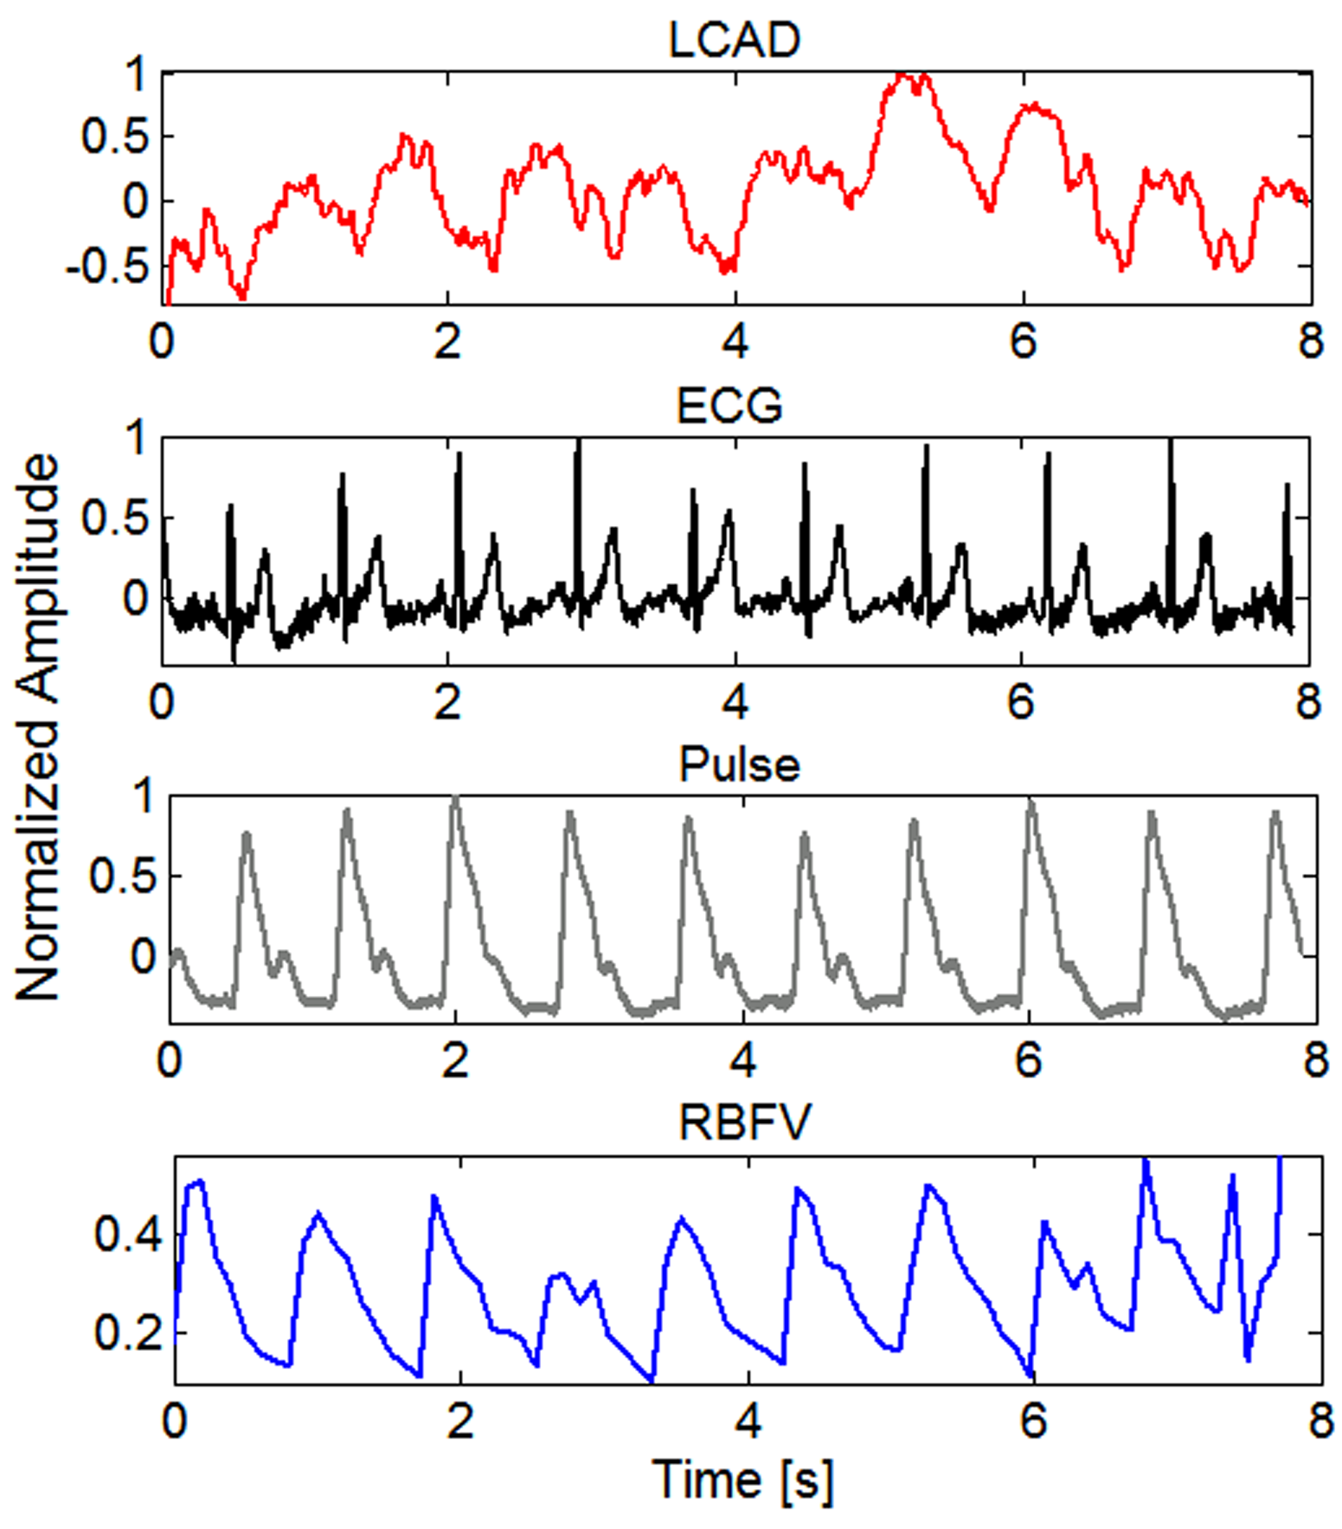
Fig. 2. Time representation of registered signals: longitudinal cornel apex displacements (LCAD), ECG signal, blood pulsation (Pulse) and retinal blood flow velocity (RBFV).

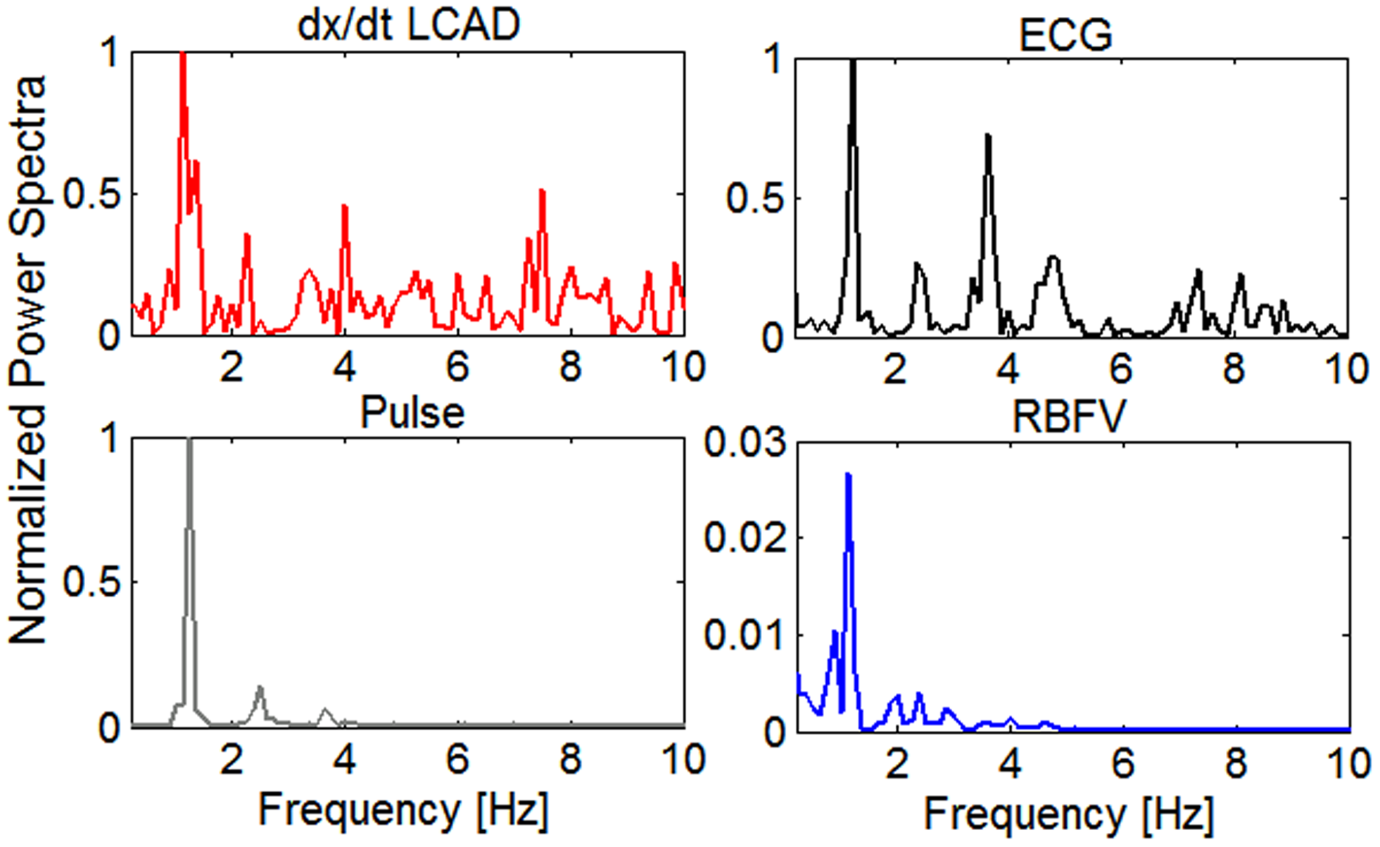
Fig. 3. Normalized power spectra of considered signals.
In Fig.3 power spectrum of longitudinal corneal apex velocity (first derivative of the position in time ) is shown, to visualize the spectral characteristic of LCAD, which decays quite fast for higher frequencies. According to properties of Fourier Transform derivative of the function is proportional to the product of the Fourier Transform of this function and the argument of Fourier Transformation (frequency). Therefore, in presented case higher harmonics are pronounced in LCAD signal’s derivative.
In all spectra (Fig.3) the frequency, which corresponds to the heart rate (about 1.2 Hz) can be observed. Frequency components of pulse and RBFV signals appear to be more similar in comparison to the spectra of LCAD and the ECG signal.
The coherence function values calculated between LCAD and RBFV (Fig.4), as well as between Pulse and RBFV indicates moderate correlation between the signals at the first harmonic of the heart rate, i.e., around 2.4 Hz.

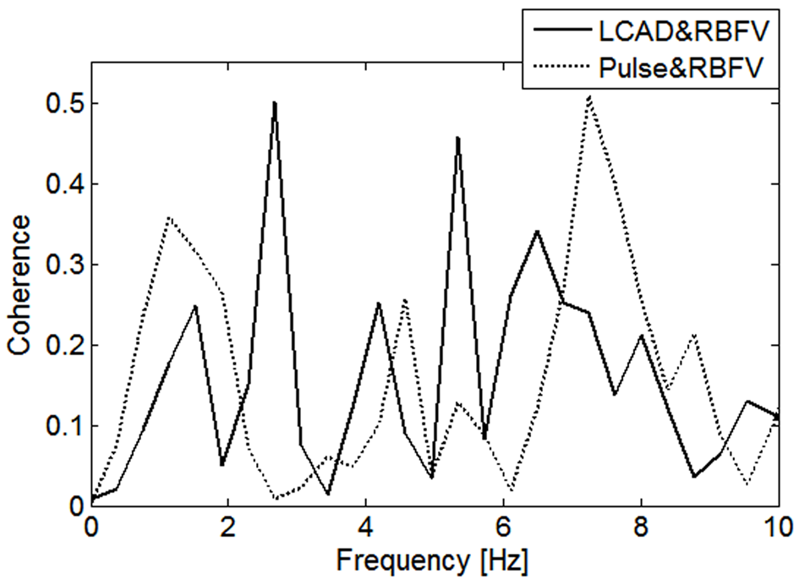
Fig. 4. The coherence function between particular pairs of signals.
The proposed method combining ultrasonic measurements of LCAD and STdOCT measurement of RBFV helps to simultaneously observe pulsatile blood flow in retinal vessels, the ocular pulse response, and the corneal displacements. It was noticed that spectral components of the acquired signals, measured with the ultrasonic and STdOCT methods, reveal certain similarities. The fundamental frequencies related to the heart rate and its first harmonic were visible in all spectra. However, the coherence between the LCAD and RBFV signals or between pulse and RBFV signals for that frequency was found to be moderate (up to 50%). This indicates that amplitude spectral characteristic of the considered signals cannot be viewed alone [5], and that techniques focusing on the phase relationships between those signals also need to be considered [19].
Noninvasive measurement of the longitudinal eye displacements and retinal blood flow signals and investigation of their spectral correlation with cardiac activity could lead to a better understanding of blood circulation on the way from heart to eye. The proposed technique might be a promising tool to ocular hemodynamic assessment and diagnostic of ocular vascular diseases.

Part of this work was supported by funds from
The Foundation for Polish Science (project VENTURES/2011-7/4 to M.E.D.). Daniel Szlag and Maciej Wojtkowski acknowledge EUROHORCS, ESF, and the Foundation for Polish Science for support within the frames of European Young Investigator Award (EURYI - 01/2008-PL).
We would like to thank Małgorzata Kowalska for help in experimental phase of this project.

References

- J. Flammer, S. Orgul; V.P. Costa, N. Orzalesi, G.K. Krieglstein, L.M. Serra, J.P.Renard, E. Stefansson, Prog. Retin. Eye Res. 21, 359–93 (2002).
- R.B. Northrop, S.S. Nilakhe, IEEE Trans. Biomed. Eng. BME-24, 139–148 (1977).
- D. Trew, C. James, S. Thomas, R. Sutton, S. Smith, Graefes. Arch. Clin. Exp. Ophthalmol. 229,553–556 (1991).
- T. Bosley, M. Cohen, W. Gee, J. Reed III, 24, 6–9 Stroke (1993).
- D. W. Evans, S. L. Hosking, S. J. Embleton, A.J. Morgan, J.D. Barlett, Graefes Arch. Clin. Exp. Ophthalmol. 240, 475–480 (2002).
- L. A. Yannuzzi, K.T. Rohrer, L.J. Tindel, R.S. Sobel, M. A. Costanza, W. Shields, E. Zang, Ophthalmology 93 (5), 611-7 (1986).
- T. H. Williamson, A. Harris, Br. J. Ophtahalmol. 78, 939-945 (1994).
- S. Yazdanafar, A. M. Rollins, J. A. Izatt, Opt. Letters 25 (19), 1448-1450 (2000).
- A. M. Rollins, S. Yazdanafar, J. K. Barton, J. A. Izatt, J. Biomed. Opt. 7 (1), 123-129 (2002).
- V. Westpfal, S. Yazdanafar, A. M. Rollins, J. A. Izatt, Opt.Letters, 27 (1), 34–36 (2002).
- R. A. Leitgeb, L. Schmetterer, W. Drexler, A. F. Fercher, R. J. Zawadzki, T. Bajraszewki, Opt. Exp. 11(23), 3116–3121 (2003).
- B. R. White, M. C. Pierce, N. Nassif, B. Cense, B. Hyle Park, G. J. Tearney, B. E. Bouma, Opt. Exp. 11 (25), 3490–3497 (2003).
- M. Wojtkowski, Appl. Opt. 49 (16), D30-61, 2010.
- M. Szkulmowski, A. Szkulmowska, T. Bajraszewski, A. Kowalczyk, M. Wojtkowski, Opt. Express 16 (9), 6008–6025 (2008).
- M. Szkulmowski, I. Grulkowski, D. Szlag, A. Szkulmowska, A. Kowalczyk, M. Wojtkowski, Opt. Exp. 14 (16), 14281–97 (2009).
- M. A. Kowalska, H. T. Kasprzak, D. R. Iskander, M. Danielewska, D. Mas, IEEE Trans. Biomed. Eng. 58 (3), 674–680 (2011).
- A. Szkulmowska, M. Szkulmowski, D. Szlag, A. Kowalczyk, M. Wojtkowski, Opt. Exp. 17 (13), 10584–98 (2009).
- H. Kasprzak, D. R. Iskander, Eye, 21, 1212–1219 (2007).
- M. E. Danielewska, D. R. Iskander, M. Kowalska, H. T. Kasprzak, Eye (submitted 2011).

