Dear Reviewer,
According to the assumptions, publication presents the current state of research about HHG in multi-jet gas puff, realized by my person, without unnecessary details, due to the small number of available pages.
As noted by the same Reviewer and as I am highlighted in the abstract and summary too, these are preliminary results, but giving hope for a promising results on the future.
Writing about the growth monochromatic, I refer to the whole results, and not to that of the spectrum on Fig. 4. Example of quasimonochromatic for different modulation gas density shows a slide below.
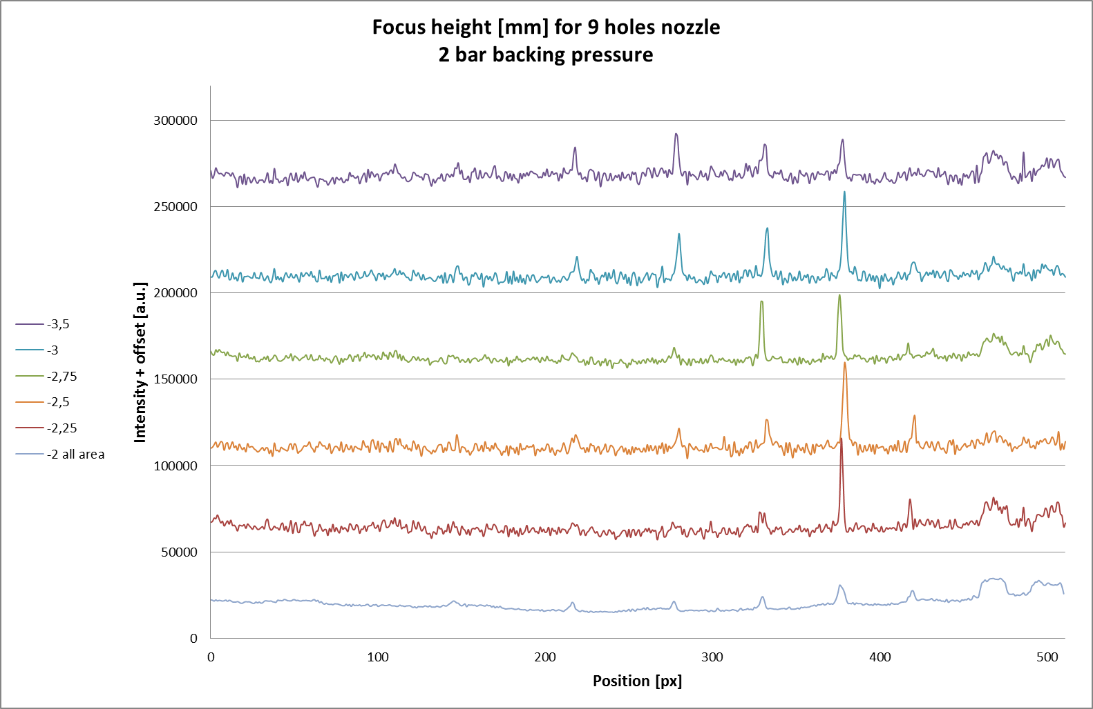
The experimental setup is standard, but with one important exception - gas target is created by synchronous pulse injection - not by a continuous flow of that "messes up" the interaction region.
Finally, I would like to emphasize once again that the publication is rather general, and not the full-length report.
I hope that my answer is enough adequate, that you consider again opinion about this article.
Best regards
Tomasz Fok

